Lab 1: Touring Landscapes using ArcGIS

Contents

Objectives 1

Google Maps 1

ArcGIS 2

Setup 2

Explore Landcover Classes 3

Extra 5

# Objectives

This lab is meant to familiarize you with landscape elements of our Santa Barbara County study area.

Your lab writeup should include all questions and your response to them as a Word document.

**Due**: noon Wednesday, January 14, 2015

# Google Maps

Let’s get a big picture view of the area in Google Maps by typing [maps.google.com](http://maps.google.com) into your browser’s address bar and then search for ”Santa Barbara County CA”. You should see the county highlighted in transparent red.

***TIP***. I recommend using Google Chrome. If you can’t launch Google Chrome from the Bren computers, then type Ctrl+Alt+Del and choose Start Task Manager, go to Processes tab, right-click on chrome.exe and End Process.

**Question 1.** According to Google Maps default cartographic perspective what are the spatially dominating human designated features (ie the large gray and green colored blobs) of Santa Barbara County? Include screenshot of map.

***TIP***. You can quickly fetch screenshots, such as of this Google map to paste into your writeup, using PrtScn button or the [Snipping Tool](http://windows.microsoft.com/en-us/windows7/products/features/snipping-tool) program that comes with Windows 7. Once captured to your clipboard simply paste (Ctrl+V) into your Word document writeup.

**Question 2.** Now switch to Earth view (lower left box). What are the hatched patterns around Lompoc and Santa Maria? Include screenshot of map zoomed into pattern.

Google has radically improved the accessibility of high resolution imagery. Check out some of the Explore features of Santa Barbara like the Earth Tour of Figuroa Mountain or Photo Sphere of the Gaviota Coast Railroad. These immersive environments give a virtual tour of these places. And the ability to elicit stakeholder feedback spatially through the web has enabled massive spatial planning efforts, such as the Marine Life Protection Act enabled through UCSB’s [SeaSketch](http://www.seasketch.org/) team.

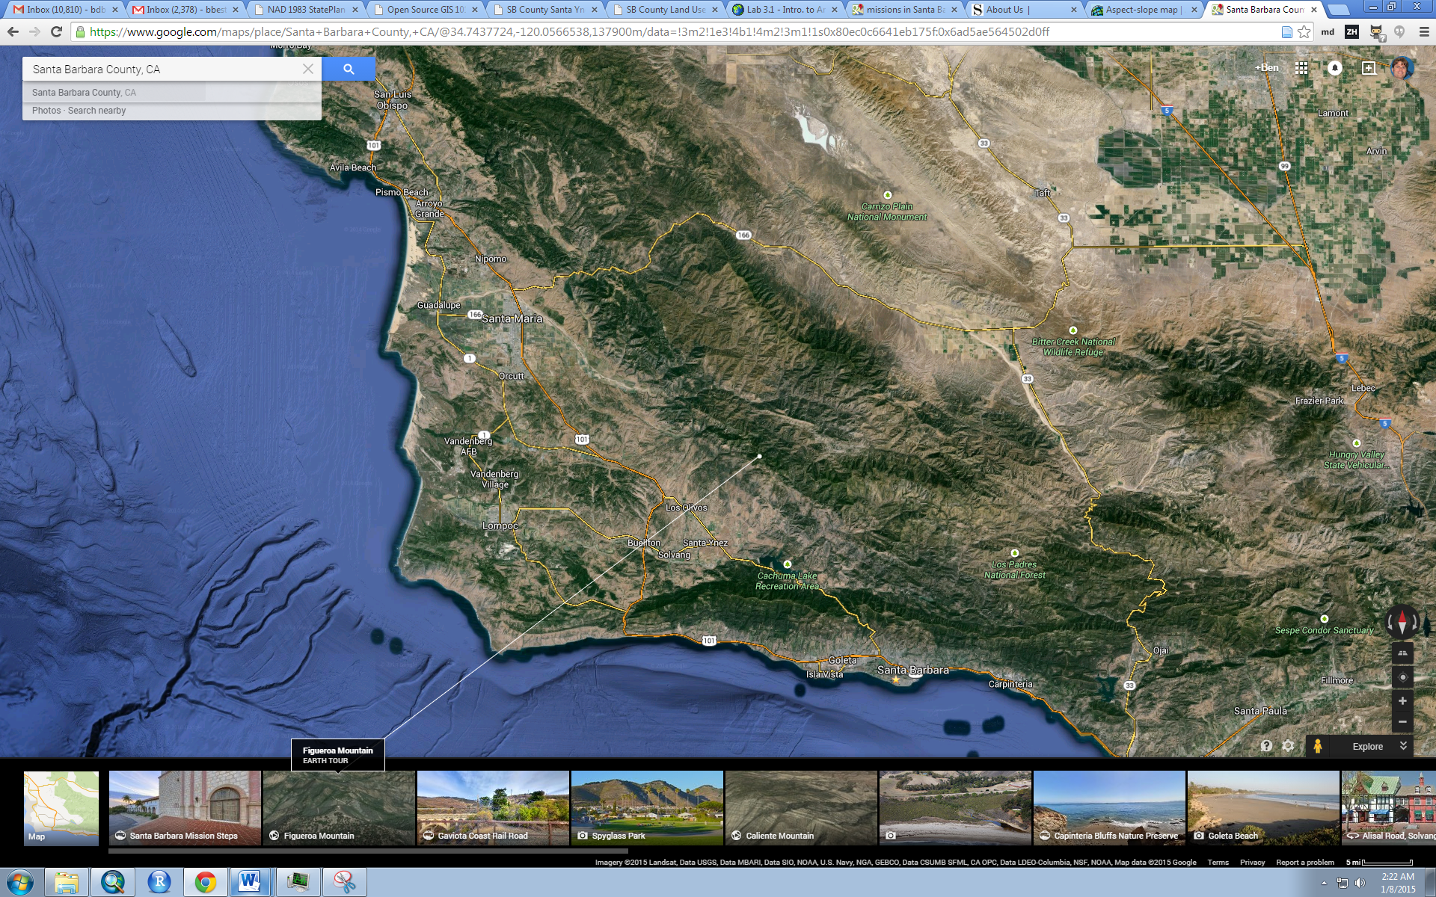

# ArcGIS

## Setup

In Windows Explorer, create your course folder here:

H:\esm215

Then copy lab1_intro from this location:

R:\Winter2015\ESM215

So H:\esm215\lab1_intro should contain:

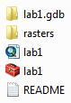

Double click on the lab1 ArcMap document  to launch ArcMap which should look like this:

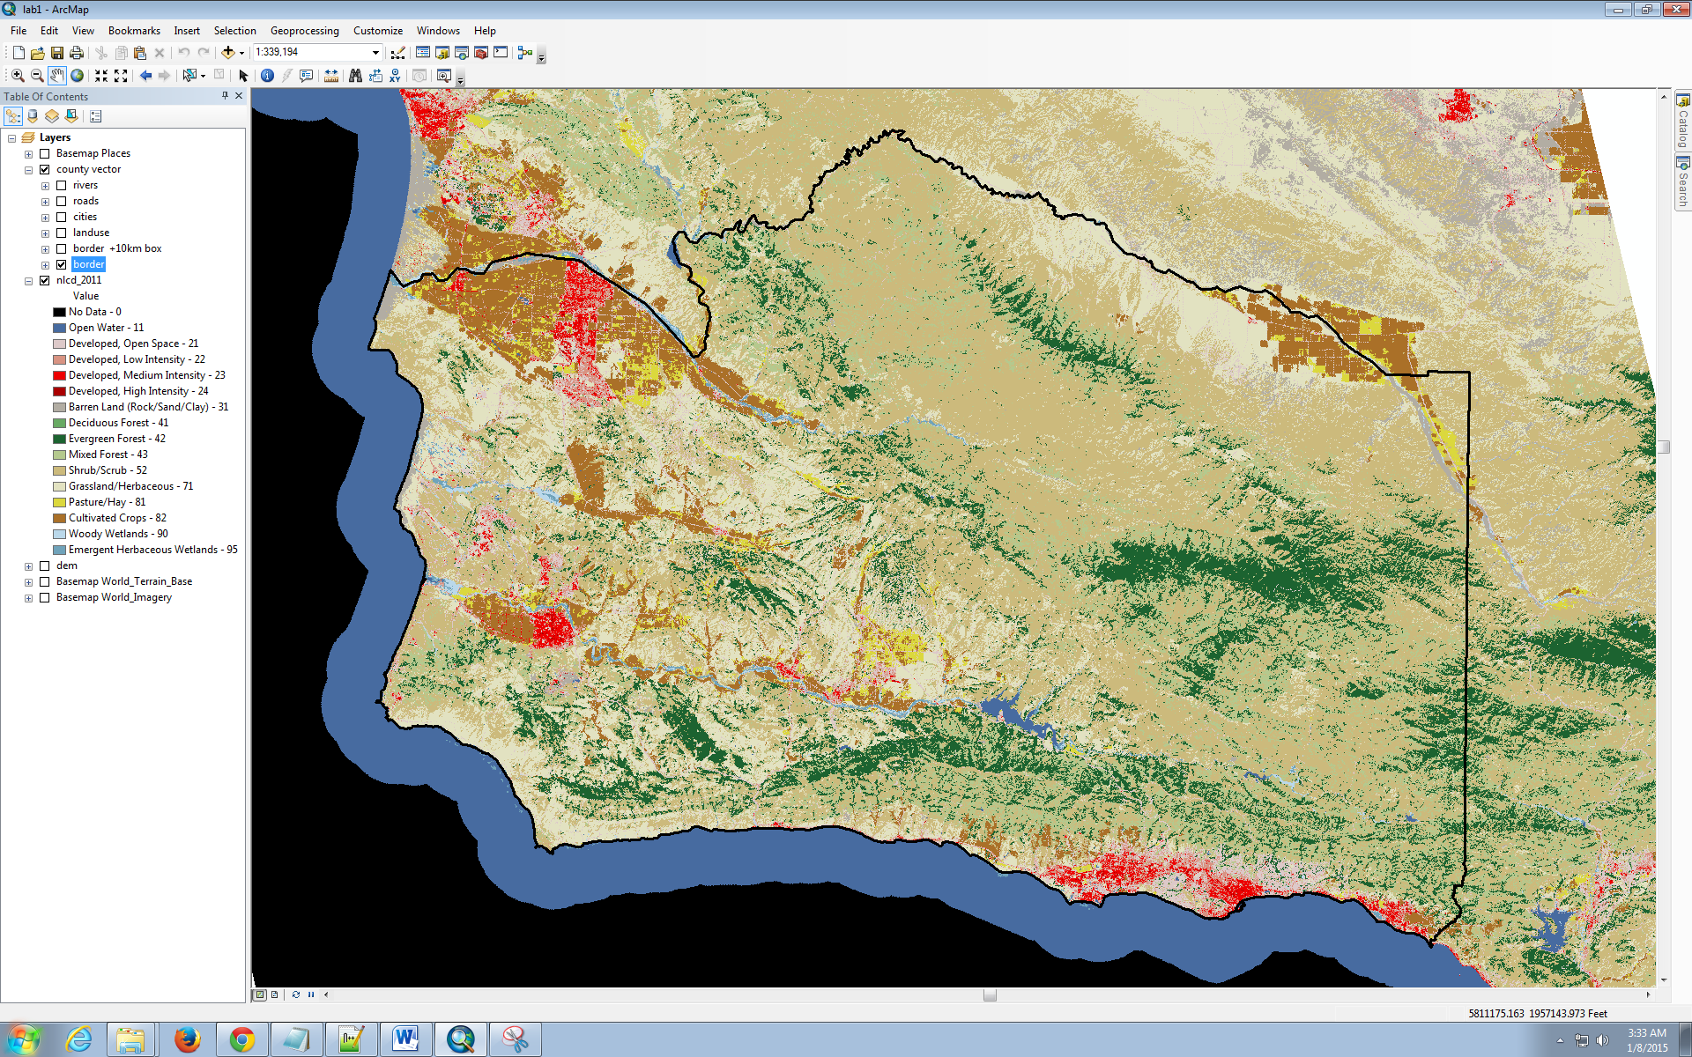

These datasets were pulled from:

* [Multi-Resolution Land Characteristics Consortium (MRLC)](http://www.mrlc.gov/): nlcd_2011 (National Land Cover Data).
* [California DEM](http://www.brenorbrophy.com/California-DEM.htm): dem (Digital Elevation Model)
* [ArcGIS Basemaps](http://resources.arcgis.com/en/help/main/10.2/index.html#//00q80000012v000000): Basemap * from ArcGIS Online
* [County of Santa Barbara GIS Catalog](http://cosb.countyofsb.org/gis/default.aspx?id=2802): all the other vector layers

The nlcd_2011 and dem layers were clipped to Santa Barbara County using the bounding box of a 10km buffer around the county boundary. The nlcd_2011 was left in its original Albers Conic Equal Area to prevent distortion of extracted values, versus the State Plane projection more specific to Santa Barbara for which the County layers were already in and the DEMs combined into a mosaic and projected into a new raster.

## Explore Landcover Classes

Turn on the other vector layers one at a time so you can begin to describe relationships.

**Question 3.** What landcover classes are most closely associated with rivers? Expand the symbology of the rivers and indicate the relationship between LEVEL and flow. Include an image of the dem layer on (nlcd_2011 layer off) with the rivers to help explain.

Next, turn on all the following layers (others off): Basemap Places, nlcd_2011, and Basemap World_Imagery layer. To compare one raster layer with the other add the [Effects](http://resources.arcgis.com/en/help/main/10.2/index.html%2000s50000001m000000) toolbar (menu Customize…, Toolbars, Effects). Select the nlcd_2011 layer from the Effects toolbar dropdown to then enable the use of Swipe or Flicker buttons for comparing this layer with the World_Imagery.

The Effects toolbar

**Question 4.** Setup your extent so that you can see all the following place names to the west of Isla Vista: Sandpiper Golf Course, coastal Ellwood, Green Meadows Golf Club and Deverough Slough. Take a screenshot. Use the Effects toolbar to compare nlcd_2011 with the World_Imagery. What discrepancies do you notice within and between these places?

**Question 5.** Now explain factors for the presence of Evergreen Forest. Try swiping/flickering the nlcd_2011 layer with Basemap World_Terrain_Base. Try also running the Slope and Aspect tools on the dem. You’ll need to turn on the Spatial Analyst extension first via menu Customize… Extensions. A model is ready for you to run to do this in lab1.tbx.

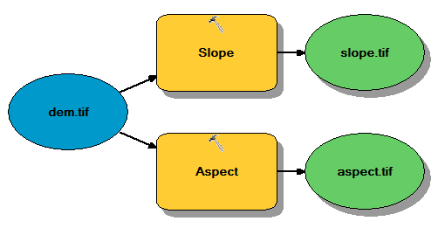

**Question 6.** More generally, what landcover classes are you most likely to find on steep versus flat slope areas?

**Question 7**. Now let’s determine the most dominant landcover types throughout the entire Santa Barbara County as well as each of the incorporated cities. In GIS parlance, we want to “tabulate” (ie sum into a table) the total area of raster “values” (ie classes in the nlcd_2011 layer) per “zone” (ie polygon of the entire county and each city polygon). Another model is setup for you to run in lab1.tbx. You just need to run the model , open the table and sort by area.

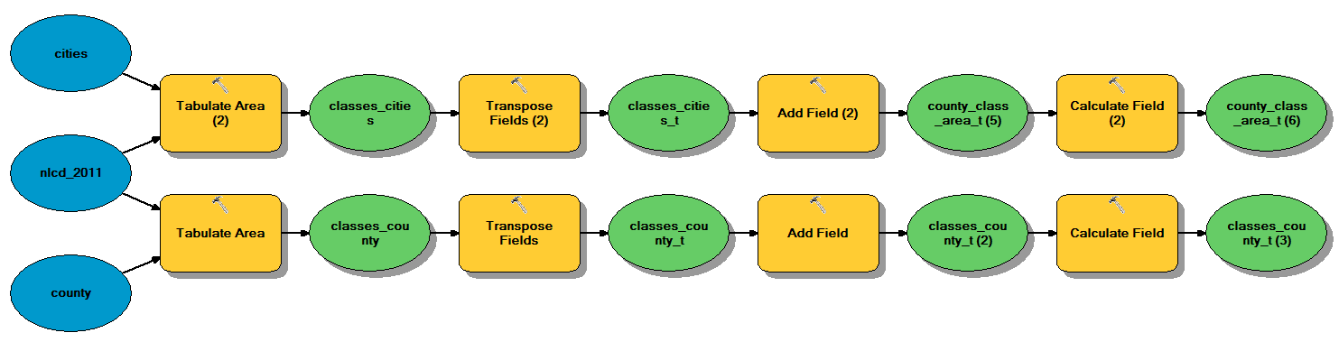

**Question 8.** A sensitive species of concern the Silvery Legless Lizard (*Anniella pulchra pulchra*) is found in forested habitats. Let’s reclassify the three forest landcover types and convert this single “forest” class into polygons so we can identify habitat “patches” at least 4 km2 in area. Run the forest patches model to accomplish this. What landcover types make up the “matrix” that the salamander would have to traverse to travel between the largest and second largest patch that occur entirely within the borders of Santa Barbara County. Include a map image of the two patches. You can use the Draw toolbar in ArcMap or the Insert Shapes tool in Word to draw a fat red line connecting the shortest distance between the two patches.

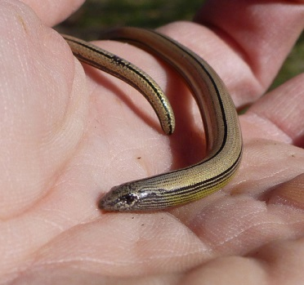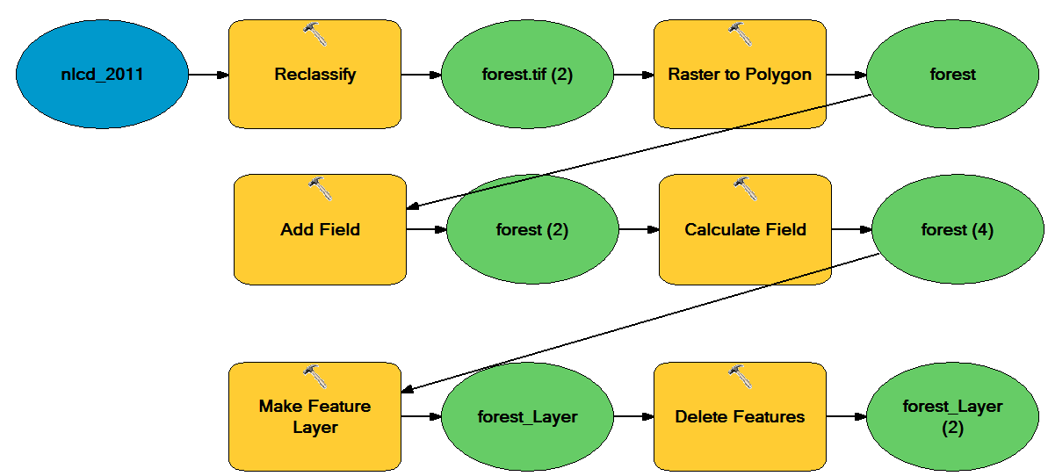

**Question 9**. What else do you notice in the landscape? Surprise me with one other observation on how the nlcd_2011 informs (or misinforms) on the landscape elements of Santa Barbara County.

# Extra

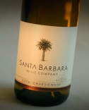Here are few more links to interesting unique Santa Barbara features:

* **Wine**. The ripe microclimates of Santa Barbara enable a thriving wine country… for now, which could be significantly altered by climate change.
  + [Touring Guide](http://www.sbcountywines.com/uploads/2/2/1/6/22166752/santa_barbara_wine_country_touring_guide_2014.pdf)
  + [AVA Chalkboard](http://savorsantabarbarafoodtours.com/wp-content/uploads/2013/10/DSC0004.jpg)
  + Hannah et al (2013) **Climate Change, Wine, and Conservation**. *PNAS*
* 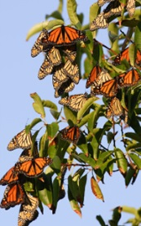**Monarchs**. These butterflies can gather by the thousands in Ellwood in the middle of a multi-generational migration between Mexico and Canada. Their presence was aided in the past by the introduction of the non-native Eucalyptus, and is threatened into the future by use of agricultural weed killers.
  + LATimes: [Monarchs, milkweed and Rachel Carson](http://www.latimes.com/opinion/op-ed/la-oe-nabhan-monarch-butterfly-extinction-20140223-story.html) (Feb 23, 2014)
  + SB Independent: [How the Eucalyptus Came to California](http://www.independent.com/news/2011/jan/15/how-eucalyptus-came-california/) (Jan 15, 2011)

# 